


Universite Claude Bernard Lyon 1
BSc in Bioinformatics — Portail Informatique
UE LIFSTAGE — Third Year Internship Report
Alternative Splicing Analysis of the Murine Circadian Transcriptome Using Nanopore Long-Read RNA-seq
Analysis of the alternative splicing landscape of the murine circadian transcriptome using Nanopore long-read RNA-seq and orthogonal validation with Illumina short-read sequencing
Student:
Gricey Rangel Trejo
BSc in Bioinformatics, 3rd year
Internship period: April 27 to August 28, 2026
Institut de Genomique Fonctionnelle de Lyon (IGFL)
Ecole Normale Superieure de Lyon — CNRS UMR 5242, Lyon, France
Internship supervisor:
Dr. Kiran Padmanabhan
Research Director and Group Leader, IGFL / Directeur de Recherche, INSERM
Academic tutor:
M. Alexandre Meyer
Universite Claude Bernard Lyon 1
Academic year 2025-2026

1. Introduction
This report describes the work carried out during a research internship at the Institut de Genomique Fonctionnelle de Lyon (IGFL), ENS Lyon, from April 27 to August 28, 2026, under the supervision of Dr. Kiran Padmanabhan (Research Director and Group Leader). The internship is part of a BSc in Bioinformatics (Licence Bioinformatique, Portail Informatique, Universite Claude Bernard Lyon 1).
DNA is the blueprint of life: a sequence of four chemical letters that every living cell reads, copies, and interprets to produce the proteins that carry out its functions. Between the blueprint and the final product lies a critical intermediate molecule called RNA, and it is at this step that a remarkable layer of complexity emerges. The same gene can give rise to multiple distinct RNA molecules, each leading to a different protein with a different function. The mechanism behind this is called alternative splicing, and understanding which version of a gene product is made, when, and in response to what, is one of the central questions of modern biology.
This question is especially relevant in the context of circadian biology. The liver operates on a precise 24-hour internal clock, and research from the IGFL laboratory has shown that this clock actively shapes not just which genes are expressed, but how their RNA is processed, including which splice variants are produced at each time of day. Disruption of the clock, through knockout of the Per1 and Per2 genes, affects splicing more severely than it affects overall gene expression (Chikhaoui, Mamgain et al., unpublished). Understanding this regulation has broader implications: disrupted splicing is associated with cancer, metabolic disorders, and neurological disease (Gehring and Roignant, 2021), making it a key area of biological research.
The internship is structured around two sequential projects. The first project explores the effect of a key SUPPA2 parameter (the splice site boundary mode) on the detected alternative splicing events, tracing how a single upstream choice propagates through the full pipeline and shapes the final output. The second, and main, project involves orthogonal validation of the laboratory's findings using publicly available Illumina short-read RNA-seq data. This report covers both projects, presenting the methods and results obtained so far, as well as the plan for the remaining internship period.

2. Host Institution and Research Team

2.1 Institut de Genomique Fonctionnelle de Lyon (IGFL)
The Institut de Genomique Fonctionnelle de Lyon (IGFL) is a joint research unit (UMR 5242) affiliated with the CNRS, the Ecole Normale Superieure de Lyon (ENS Lyon), and the Universite Claude Bernard Lyon 1. Located on the ENS Lyon campus in Lyon, France, it brings together research groups working on genomics, developmental biology, and evolutionary biology, with a shared interest in understanding how genes are regulated and what happens when that regulation changes.
The institute supports both experimental and computational research, with access to high-throughput sequencing, proteomics, and imaging platforms. This makes it a good fit for interdisciplinary projects that combine wet-lab biology with bioinformatics, which is the nature of the work described in this report.

2.2 The Padmanabhan Research Group
The internship was carried out within the research group led by Dr. Kiran Padmanabhan (Research Director and Group Leader at IGFL). The group studies how the circadian clock, the internal 24-hour timer present in most cells, controls gene activity in the liver. A key focus is the relationship between the clock and RNA processing: not just which genes are turned on or off, but which version of a transcript (an alternative version of the same RNA molecule, also called an isoform) is produced and how the clock shapes that choice over time. This includes the study of alternative splicing, chromatin organization (the compact structure of DNA and proteins in the cell nucleus), and the role of specific regulatory factors in connecting the two.
The RNA-seq data used in this project was generated from samples prepared by the Padmanabhan lab at IGFL and sequenced in collaboration with Prof. Yutaka Suzuki's group at the University of Tokyo, using Oxford Nanopore direct RNA sequencing. Wild-type (WT) mice were kept in 12-hour light/dark cycles, then transferred to constant darkness one day before tissue collection, to isolate the internal clock from external light cues. Liver samples were collected every 4 hours over 24 hours, covering circadian times CT0 through CT20. A separate group of mice with a double knockout of Per1 and Per2 (PerDKO), which have no functional circadian clock, were also kept in constant darkness and sampled at CT8 and CT20. This setup gives three conditions to compare computationally: WT at CT8, WT at CT20, and PerDKO at CT20.Mice
The IGFL group's most recent findings, currently under review for publication (Chikhaoui, Mamgain et al., unpublished), show that PERIOD proteins influence how splicing regulatory factors are recruited to chromatin, and that this has measurable consequences on which transcript isoforms are produced across the circadian cycle. The computational validation of these findings is the main goal of Project 2 of this internship.

2.3 Team and Working Environment
Day-to-day supervision was provided by Khushi Mamgain (PhD student and co-first author of the manuscript under review), who guided the scientific direction of the analyses and provided the processed Nanopore datasets used in Project 1. Additional input on the computational pipeline for Project 2 was provided by Dr. Bharath Ananthasubramaniam (collaborating computational biologist, based in Berlin), who contributed the starting pipeline scripts. Wet-lab and biochemistry validation of the manuscript's findings is handled by Constanza Blanco, a lab member working on the experimental side of the project.
For Project 2, the RNA-seq data comes from a publicly available dataset on NCBI GEO (accession GSE171975), generated by the Asher lab (Aviram et al., 2021) from mouse liver samples at CT20, covering both WT and PerDKO conditions. The computational work was carried out on a laboratory-provided Mac workstation, using Bash and Python, with version control managed through GitHub.

3. Scientific and Technical Background

3.1 From gene to isoform: the central dogma and alternative splicing
To understand the computational work carried out in this internship, it helps to have a basic picture of how genetic information flows in a cell. A gene is a region of DNA that encodes a functional product. When a gene is activated, the DNA is first transcribed into a precursor RNA molecule called pre-mRNA. This pre-mRNA contains both coding regions (exons) and non-coding regions (introns). Before the molecule can be used by the cell, the introns are removed and the exons are joined together in a process called splicing, producing a mature messenger RNA (mRNA). The mRNA is then translated into a protein.
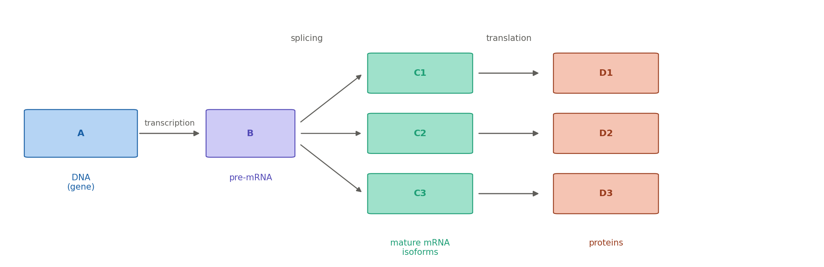
Figure 1. Central dogma of molecular biology. A = DNA (gene), B = pre-mRNA, C = mature mRNA isoform, D = protein. One gene can produce multiple isoforms via alternative splicing.
What makes this process particularly interesting from a computational standpoint is that the splicing step is not always identical. Different combinations of exons can be joined, producing distinct transcript isoforms from the same gene. This is called alternative splicing (AS). Of all human genes, only 5% consist of a single exon, and more than 90% are alternatively spliced (Gehring and Roignant, 2021), making it one of the main mechanisms by which a compact genome can generate a large diversity of functional products.
SUPPA2 detects and quantifies seven types of alternative splicing events (Trincado et al., 2018):
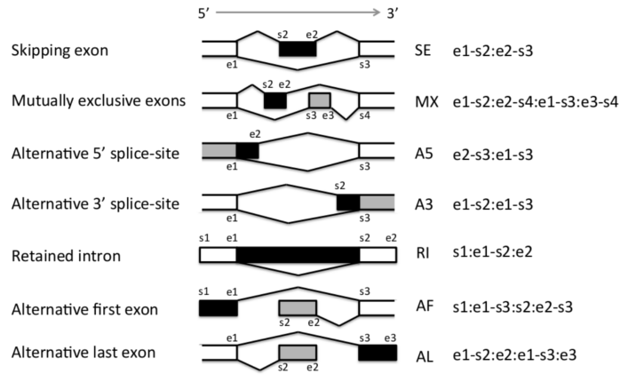
Figure 2. The seven alternative splicing event types defined by SUPPA2. Adapted from Trincado et al., 2018 / SUPPA2 GitHub repository (github.com/comprna/SUPPA).
SE (skipped exon): an exon is present in one isoform and absent in the other.
RI (retained intron): an intron that is normally removed stays in the mature mRNA.
A3 (alternative 3' splice site): the 3' boundary of an intron is shifted, producing a longer or shorter exon.
A5 (alternative 5' splice site): same as A3 but at the 5' end of the intron.
MX (mutually exclusive exons): two exons exist, but only one appears per isoform.
AF (alternative first exon): the first exon differs between isoforms.
AL (alternative last exon): the last exon differs between isoforms.
In this project, the analysis focused on three of these seven types: A3, A5, and RI. These are the event types most sensitive to the boundary parameter explored in Project 1. SE, MX, AF and AL were also detected but showed no sensitivity to the boundary parameter change.
The quantification of how often each isoform is produced is captured by the PSI (Percent Spliced In) metric. PSI is a value between 0 and 1 representing the proportion of transcripts at a given locus (the specific genomic location of a gene or event) that include a particular splicing event. A PSI of 0 means the event is never included; a PSI of 1 means it is always included. When comparing two conditions, the difference in PSI (dPSI) quantifies how much the splicing changes between them. This is the core metric used throughout both projects.

3.2 Circadian context: why alternative splicing matters here
The circadian clock is a molecular feedback loop present in most cells of the body. In the liver, it coordinates gene expression over a 24-hour cycle, regulating metabolism, detoxification, and other functions. Importantly, the clock controls not just transcription but the entire RNA lifecycle, including which splice variants are produced at each time of day. Splicing factors are themselves proteins under circadian control, meaning the clock actively determines which isoforms get made and when. Research from the IGFL group showed that the proteins encoded by the Per1 and Per2 clock genes influence how splicing regulatory factors are recruited to chromatin. When these proteins are knocked out (PerDKO mice), the splicing landscape of the liver is significantly altered, with PerDKO livers exhibiting nearly threefold more mis-spliced than mis-expressed transcripts (Chikhaoui, Mamgain et al., unpublished).
Understanding this regulation has direct relevance beyond the model organism. Disrupted splicing is increasingly recognized as a driver of disease: spliceosome mutations are found in certain cancers, circadian disruption in the liver is associated with metabolic disorders and elevated cancer risk, and splicing defects underlie neurological conditions such as spinal muscular atrophy (Gehring and Roignant, 2021). The IGFL group's work on how the clock shapes splicing therefore sits at the intersection of circadian biology, RNA biology, and human health.

3.3 Two sequencing technologies: Nanopore and Illumina
Both projects involve RNA-seq data (RNA sequencing data, measuring which RNA molecules are present in a sample and in what quantities), but from two different sequencing platforms.
 | Nanopore (long-read) | Illumina (short-read)
Read length | Up to ~50,000 nt | ~150 nt
Output | Full-length isoforms | Short fragments
Isoform detection | Direct, unambiguous | Inferred from fragments
Sequencing depth | Lower | Higher
Error rate | Higher (raw reads) | Lower
Use in this project | Primary splicing data (Project 1) | Orthogonal validation (Project 2)
Table 1. Comparison of Nanopore long-read and Illumina short-read RNA-seq.

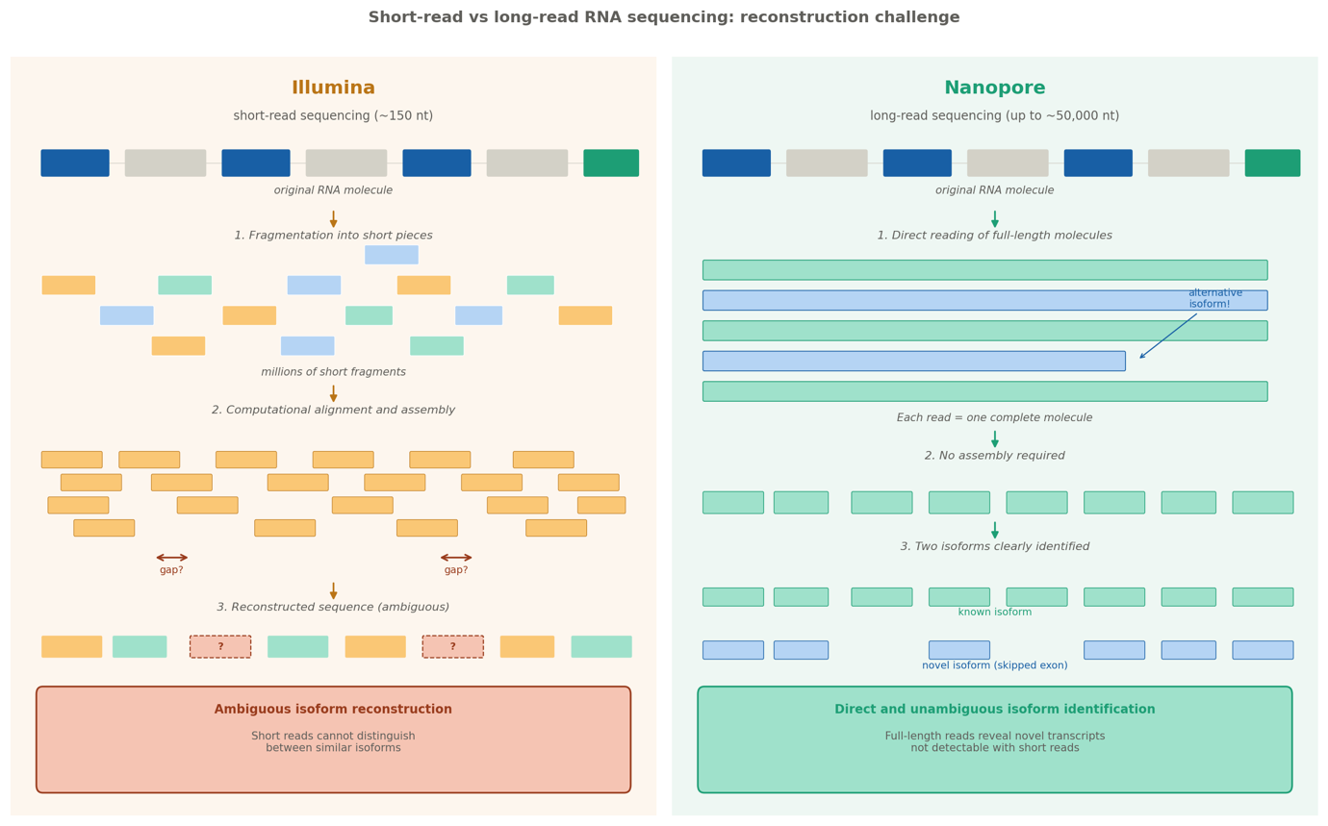
Figure 3. Illumina short-read sequencing requires computational assembly of fragments, introducing ambiguity. Nanopore long-read sequencing reads full-length molecules directly, enabling unambiguous isoform identification.
Nanopore long-read sequencing reads entire RNA molecules from end to end, producing reads that can span thousands of nucleotides. This makes it possible to directly observe which exons are present in a single transcript without having to reconstruct isoforms from short fragments. Benchmarking studies have shown that long-read data improves read-to-transcript assignment and transcript-level abundance estimation compared to short reads, particularly for genes with many similar isoforms (Chen et al., 2021). Illumina short-read sequencing, by contrast, produces millions of short fragments (around 150 nucleotides each) that must be mapped back to a reference to infer which isoforms were present. However, Illumina data is much deeper and more widely available in public repositories.
Early applications of Nanopore sequencing to mouse liver transcriptomics were limited to relatively low read numbers, around 500,000 reads (Sessegolo et al., 2019). The dataset used in this project, generated by the Padmanabhan lab in collaboration with the University of Tokyo, contains approximately 70 million reads (Chikhaoui, Mamgain et al., unpublished), representing a substantial increase in depth that enables a more comprehensive view of the splicing landscape.
The key point for this project is that both platforms are measuring the same biological phenomenon from different angles. If the splicing events detected from Nanopore data are also detectable in independent Illumina data from a comparable experiment, that is strong evidence that the findings reflect real biology rather than technical artifacts of the sequencing method.

3.4 Key tools
SUPPA2 is the main splicing analysis tool used in both projects (Trincado et al., 2018). It was chosen because it is already established in the IGFL laboratory's workflow (Chikhaoui, Mamgain et al., unpublished) and is specifically designed for transcript-level splicing quantification. Given a reference transcriptome annotation (a GTF file), SUPPA2 first catalogs all possible alternative splicing events, then computes PSI values from transcript expression estimates, and finally runs a statistical test ("diffSplice") to identify events significantly different between conditions. The reference annotation used is a custom GTF derived from the laboratory's Nanopore data, built on the mouse genome assembly GRCm39 (mm39), containing annotated and novel isoforms discovered by the lab (Chikhaoui, Mamgain et al., unpublished).
Salmon is a transcript quantification tool (Patro et al., 2017) that estimates how much each transcript is expressed in TPM (Transcripts Per Million) from RNA-seq reads and a reference transcriptome. It uses a lightweight alignment approach that is very fast compared to traditional aligners. Its output feeds directly into SUPPA2 for PSI computation.
IGV (Integrative Genomics Viewer) is a genome browser (Robinson et al., 2011) used to visually inspect splicing events at specific loci (the specific genomic location of a gene or event). After identifying candidate events computationally, IGV was used to verify that the transcript structures detected by SUPPA2 were consistent with the underlying read data.
Bash was used for all pipeline automation. It is the standard scripting language in bioinformatics for orchestrating multi-step tools on large data files, and is widely used in high-performance computing environments.
Python was used for all data analysis and visualization, implemented in Jupyter notebooks. Bioinformatics commonly relies on R for statistical analysis, and coursework at UCBL included R extensively. Python was chosen here deliberately: it offered an opportunity to apply a language from the CS curriculum to a biological problem, and the pandas and matplotlib ecosystem is well suited to the tabular data formats produced by SUPPA2.

4. Computational Environment and Project Organization

4.1 Software and tools
The table below summarizes the main tools and languages used throughout the internship.

Tool / Language | Version | Role in the project
SUPPA2 | v2.3 | Alternative splicing event detection and PSI quantification
Salmon | v1.5.2 | Transcript expression quantification (TPM)
IGV | v2.19.7 | Genome browser for visual inspection of splicing events
Python | 3.8.20 (suppa_env) | Data analysis, filtering, and figure generation
pandas | latest in suppa_env | Tabular data manipulation
matplotlib | latest in suppa_env | Figure generation
matplotlib-venn | latest in suppa_env | Venn diagram visualizations
Bash / zsh | macOS zsh | Pipeline automation and file processing
GitHub | git | Version control and code repository (griceyrt/Internship)
VSCode | latest | Development environment for notebooks and scripts
Notion | web | Lab notebook, biology glossary, daily logs
Table 2. Software and tools used in the internship.
All bioinformatics tools (SUPPA2, Salmon) were run inside a dedicated Python virtual environment called suppa_env (Python 3.8.20), created at the start of the internship to ensure reproducibility and avoid dependency conflicts. The analysis code was developed in VSCode using the same environment as the execution kernel.

4.2 Repository structure
All code produced during the internship is tracked in a public GitHub repository (griceyrt/Internship). The repository is organized into two main project folders, a shared report folder, and the SUPPA2 tool directory. Figure 4 shows the full structure.

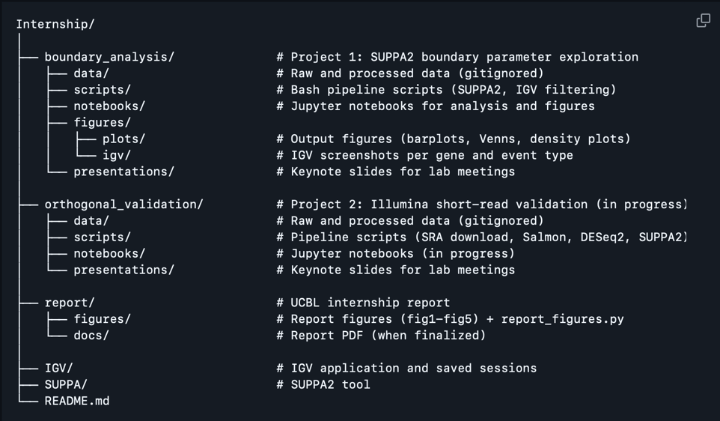
Figure 4. Repository structure of the internship codebase (griceyrt/Internship, GitHub).
Raw data and large biological files are excluded from version control via a .gitignore file, keeping the repository lightweight and focused on code.

4.3 Workflow overview
The general computational workflow follows three stages. First, Bash scripts handle the heavy lifting: running SUPPA2 "generateEvents" to catalog all splicing events from the reference, running "psiPerEvent" to compute PSI values from Salmon TPM outputs, and running "diffSplice" to compare conditions. Second, Python notebooks handle filtering, comparison, and visualization: loading SUPPA2 outputs into pandas dataframes, computing set operations between event populations, and generating figures with matplotlib. Third, IGV is used manually to inspect candidate events, verify transcript structures, and produce screenshots for reporting.
This separation between pipeline execution (Bash) and analysis (Python) kept the workflow modular and easy to debug. Each stage produces clearly named output files that serve as inputs to the next, making the full pipeline traceable from raw TPM files to final figures.

5. Project 1: Exploring the Effect of the SUPPA2 Boundary Parameter

5.1 Context and objective
SUPPA2's "generateEvents" module catalogs all possible alternative splicing events from a reference transcriptome. One of its key parameters is the boundary mode, which determines how precisely a splice site must match the annotated coordinates in the reference in order to be detected. In strict mode (the default, and the mode used in the manuscript), splice sites must match exactly. In variable mode, a tolerance of N nucleotides is allowed on either side, meaning that events with splice sites slightly offset from the annotation are still detected.
The question explored in this project is: what happens when you change this parameter? Specifically, does relaxing the boundary at the very beginning of the pipeline, before any read counts or statistical tests are involved, lead to a meaningfully different set of detected events downstream?

5.2 Data and pipeline setup
The analysis used 9 samples from the laboratory's Nanopore RNA-seq dataset, covering three conditions with 3 biological replicates each (Table 1). The reference annotation used was transcriptome_productivity.gtf, the laboratory's custom GTF file built on GRCm39 (mm39). Transcript expression values (TPM) were pre-computed with Salmon by Khushi and provided as input.

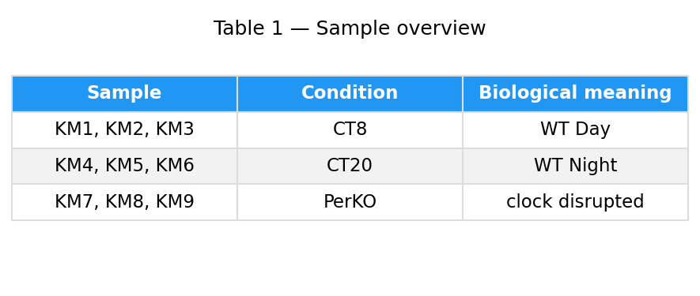
Table 3. The 9 Nanopore RNA-seq samples used in Project 1.

The pipeline follows the approach established in the manuscript: "generateEvents" identifies events from the rebuilt transcriptome, PSI values are computed from batch-corrected expression values using "psiPerEvent", and "diffSplice" identifies differential splicing with events at p < 0.05 and dPSI > 0.1 considered significant (Chikhaoui, Mamgain et al., unpublished). "generateEvents" was run six times: once in strict mode, and five times in variable mode with tolerances of 1, 3, 5, 10, and 20 nucleotides, automated through run_suppa.sh.

5.3 Results

5.3.1 Variable mode detects substantially more events
Switching from strict to variable 1nt mode substantially increases the number of detected events for A3, A5, and RI. SE, MX, AF and AL counts remain identical across all boundary modes, confirming that the change is specific to events defined by a splice site boundary.
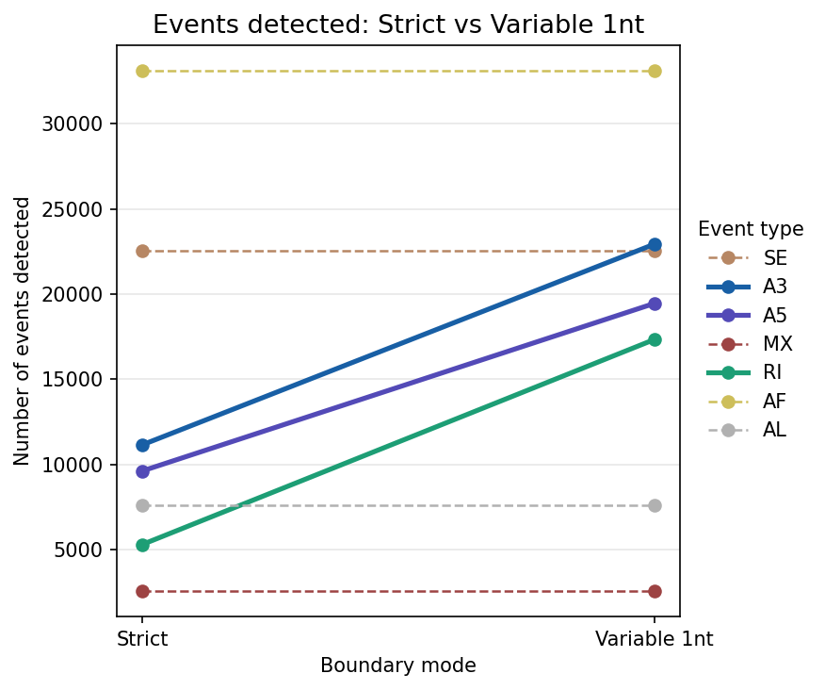
Figure 5. Event counts for each event type in strict vs variable 1nt mode. A3 increases from 11,164 to 22,932, A5 from 9,630 to 19,456, and RI from 5,316 to 17,337. SE, MX, AF and AL are unchanged.
When extended to all six boundary modes, counts for A3, A5, and RI increase from strict to variable 1nt, then plateau from 1nt onward. This plateau indicates that variable 1nt captures essentially the same set of events as any larger tolerance, making it the natural comparison point.
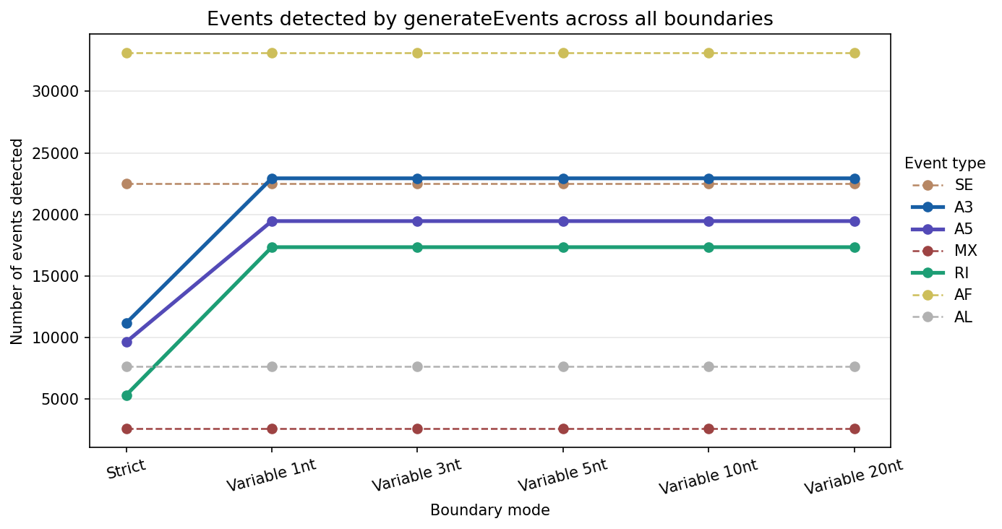
Figure 6. Event counts across all six boundary modes (strict, 1nt, 3nt, 5nt, 10nt, 20nt). Counts plateau after 1nt for A3, A5, and RI.

5.3.2 Variable mode is a superset of strict mode
Events detected by strict mode were compared to those detected by variable 1nt mode. This required a coordinate reformatting step, as strict and variable modes use different internal representations for the same event types. A strand-aware reformatting function was implemented in Python to make the IDs comparable.
After reformatting, all strict events were found within the variable event set, with zero exceptions across all three event types. This is expected and serves as a computational sanity check: relaxing a constraint can only add events, never remove them. Variable mode is therefore a true superset of strict mode.
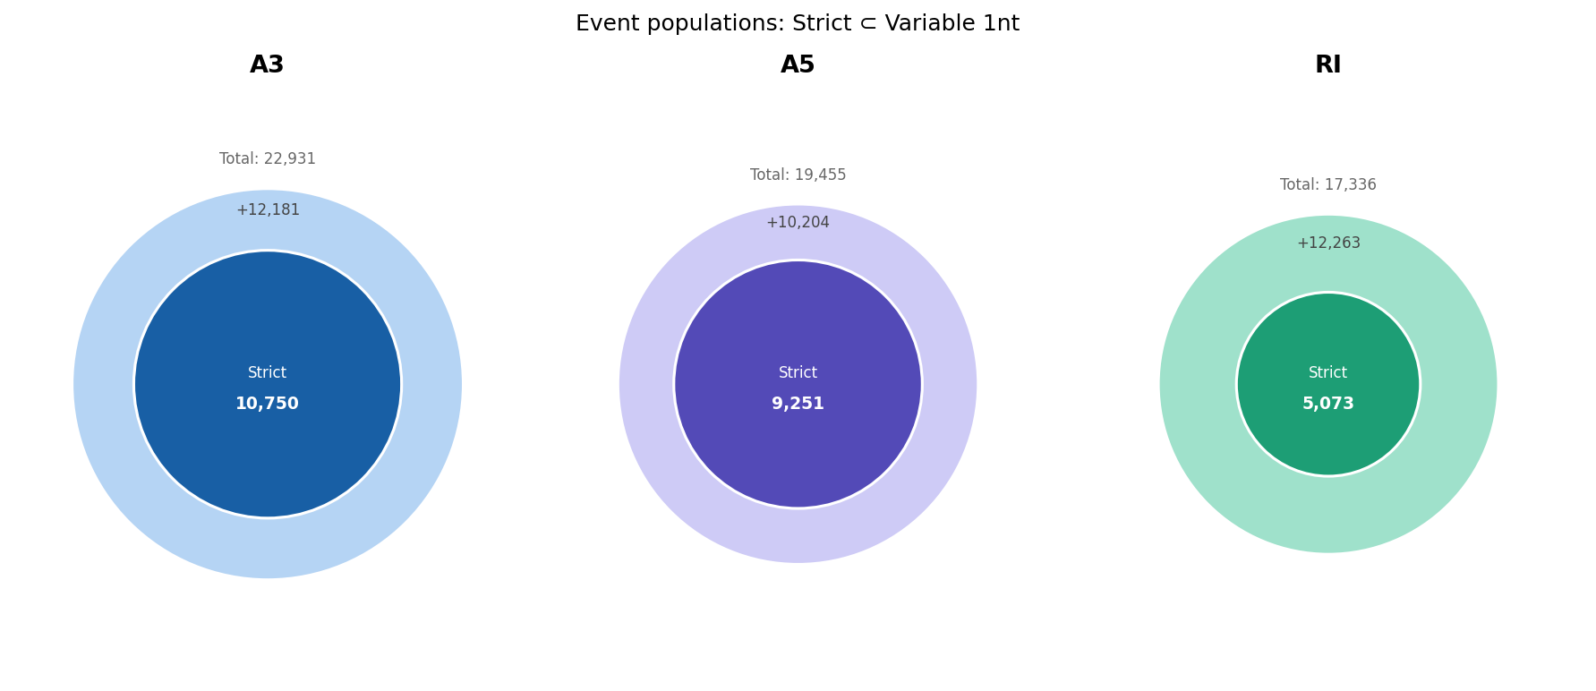
Figure 7. Strict mode events (inner) are fully contained within variable 1nt mode events (outer), confirmed for A3, A5, and RI.

5.3.3 Gene-level perspective: novel genes and novel transcripts
Variable 1nt mode detects events in thousands of genes that strict mode misses entirely, with a subset involving novel UUID transcripts (see Figure 8).
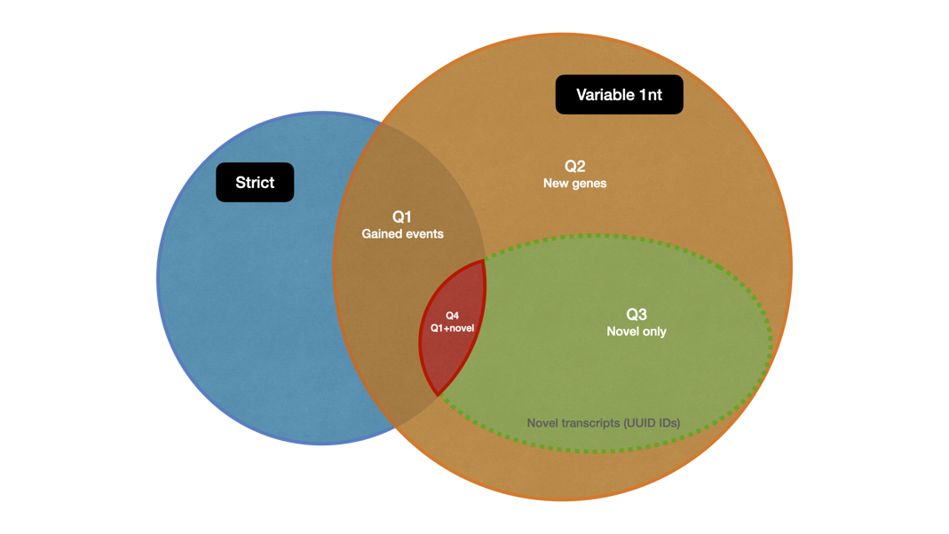
Figure 8. Gene populations defined by comparing strict and variable 1nt mode. Q1: genes gaining new events in variable mode; Q2: genes detected only in variable mode; Q3: variable-only events from novel (UUID) transcripts; Q4: subset of Q1 involving novel transcripts.
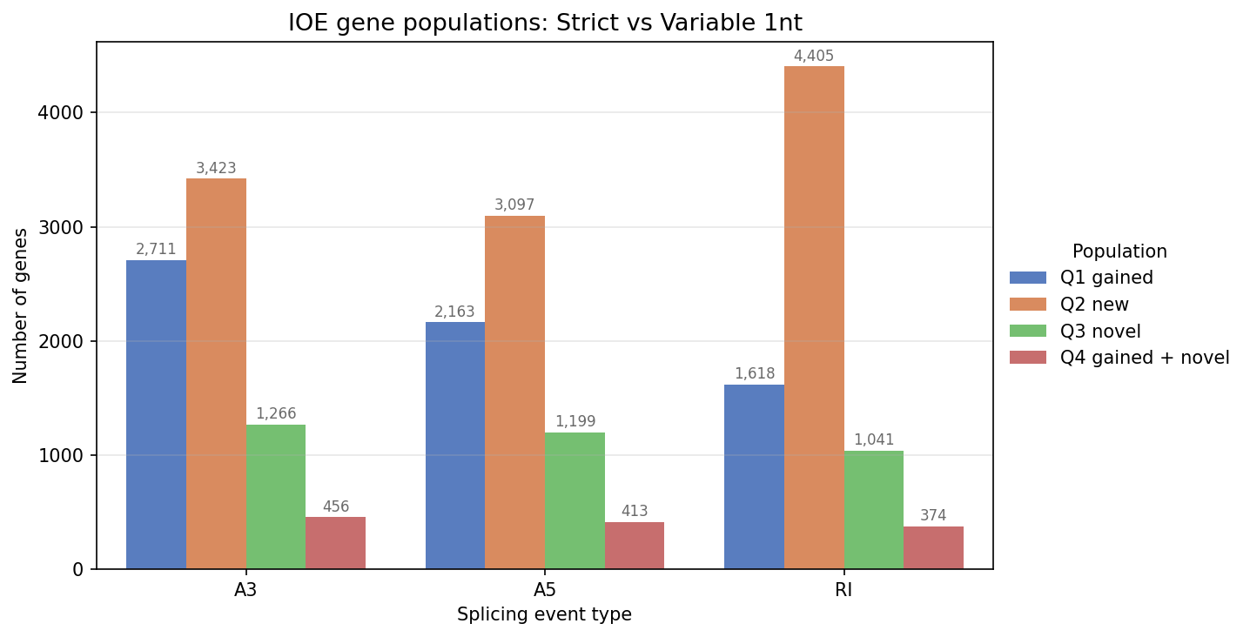
Figure 9. Gene counts per population (Q1–Q4) for A3, A5, and RI.

5.3.4 PSI values are consistent between modes for shared events
For events detected by both modes, a density plot of the PSI difference (dPSI = PSI_strict minus PSI_variable) shows a sharp peak at zero for all three event types, with mean dPSI values between 0.025 and 0.034. Both modes agree on the quantification of events they share.
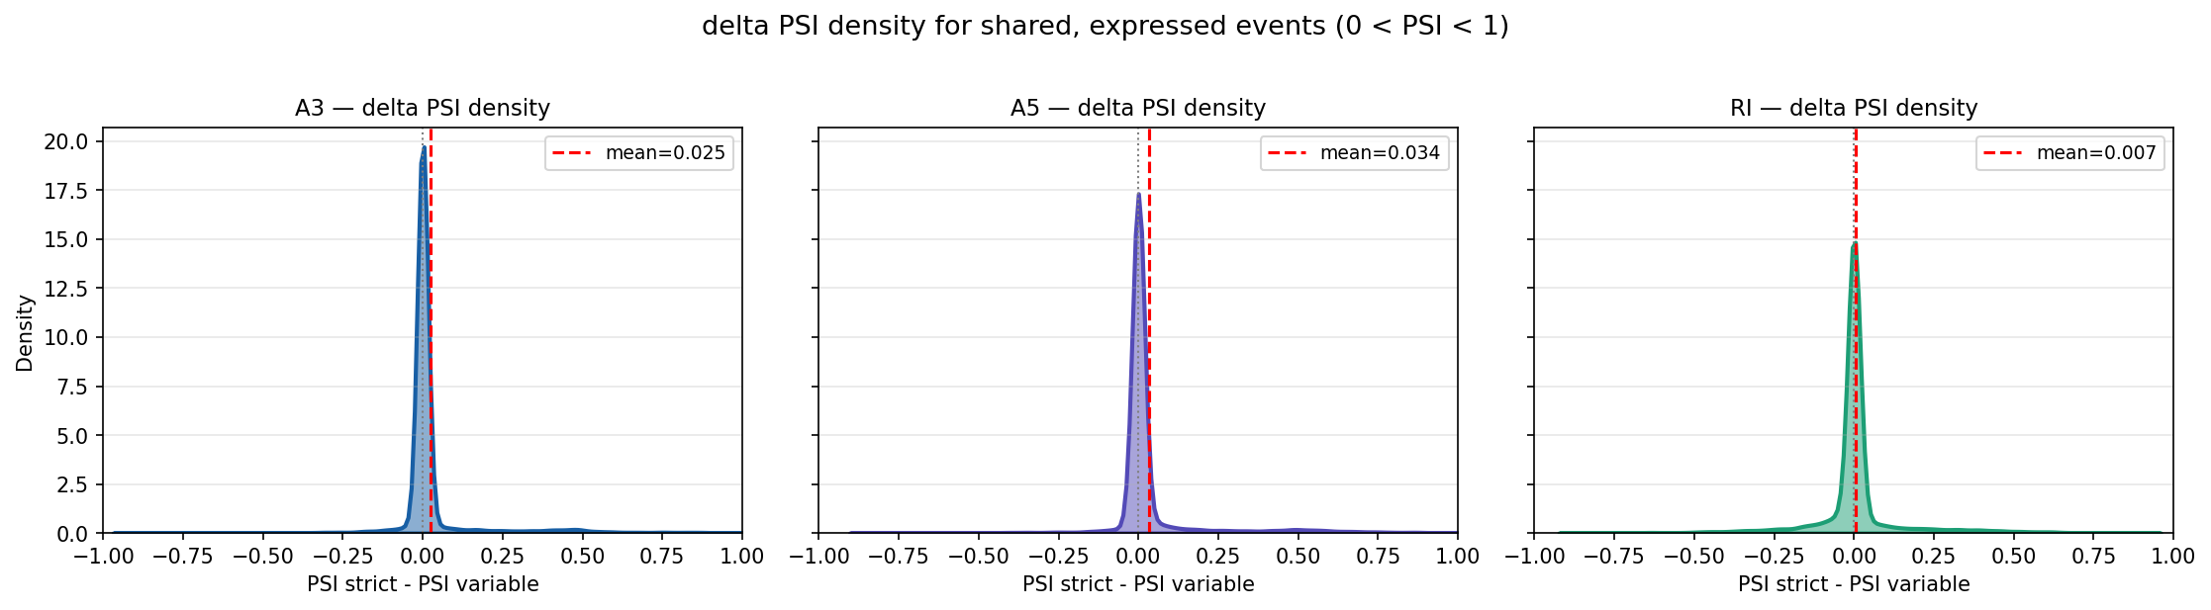
Figure 9. Density plot of PSI difference for events shared between strict and variable 1nt mode. The peak at zero confirms quantification consistency for shared events across A3, A5, and RI.

5.3.5 Significant differential splicing events
After filtering (|dPSI| > 0.1, p < 0.05), strict mode yields 45 A3, 47 A5, and 13 RI significant events. Variable 1nt mode yields 73 A3, 76 A5, and 64 RI. Most strict significant events are also found in the variable significant set, confirming that variable mode is a superset at the level of statistically filtered results as well.
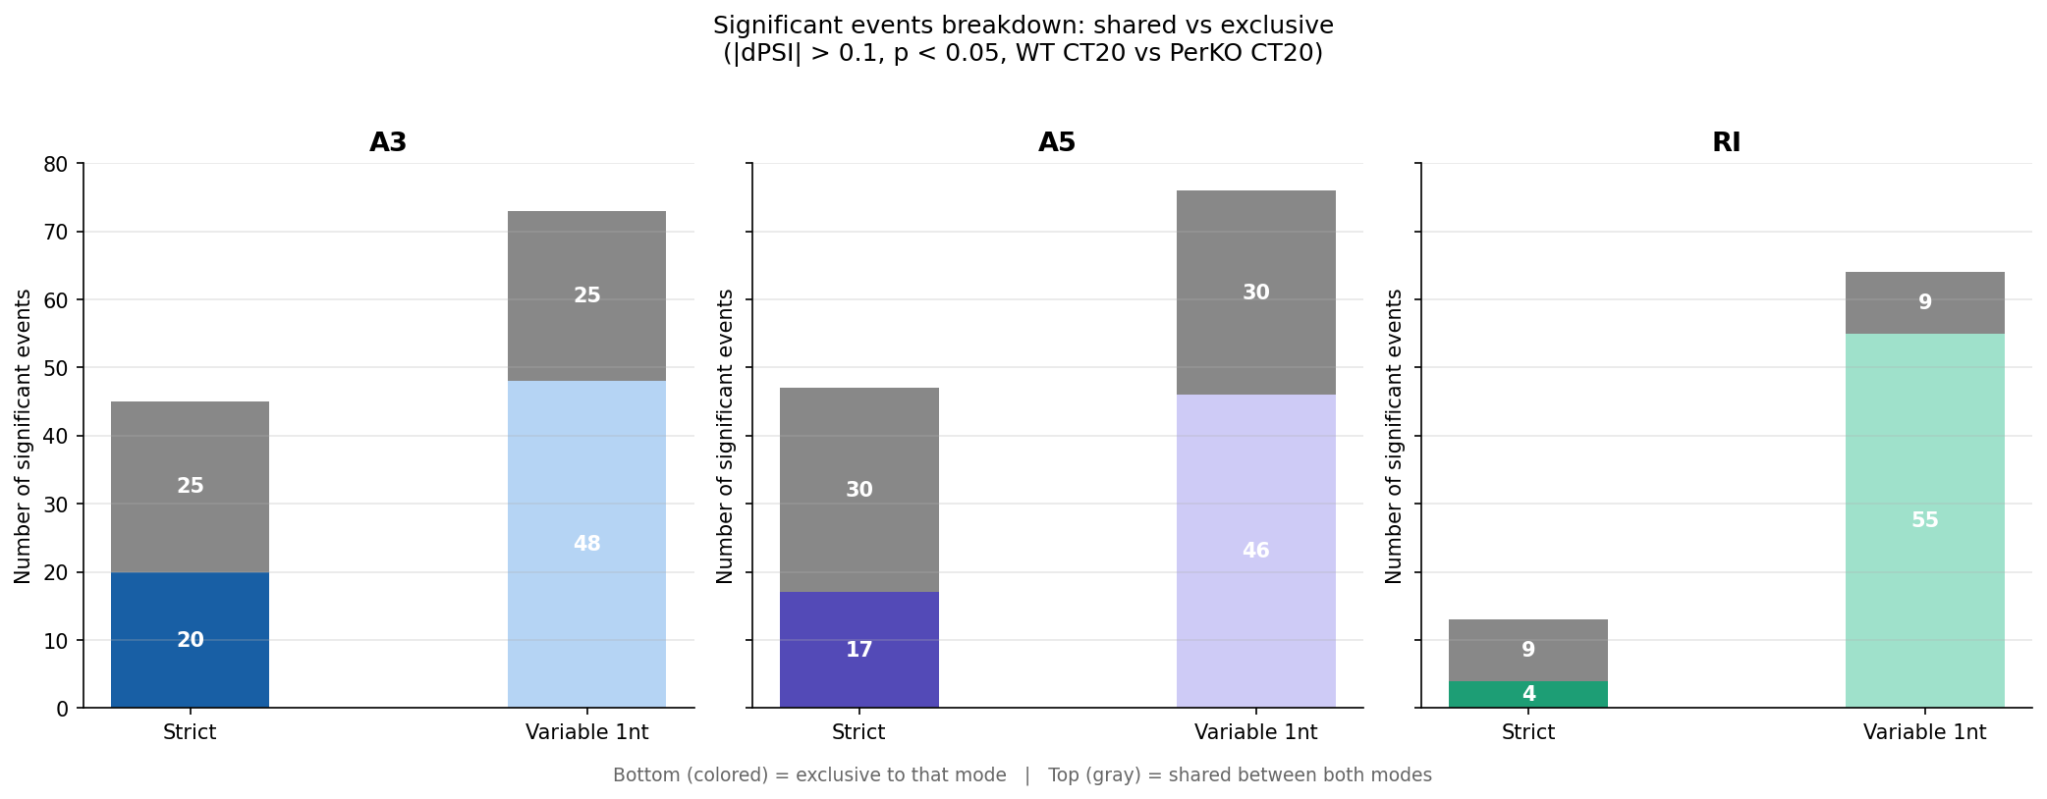
Figure 10. Significant differentially spliced events (|dPSI| > 0.1, p < 0.05) comparing WT CT20 vs PerDKO CT20 in strict vs variable 1nt mode, for A3, A5, and RI.

5.4 Case study: gene C8g (ENSMUSG00000015083)
To illustrate the practical impact of the boundary parameter, one candidate event was examined in detail using IGV. Gene C8g shows an A3 event at chr2:25,389,127-25,389,517 with a dPSI of 0.952 between strict and variable mode in sample KM4 (PSI_strict = 0.977, PSI_variable = 0.025). This large discrepancy arises because variable mode detects a novel transcript (UUID identifier c765a871) at that locus that strict mode cannot see. The same locus also has a variable-only RI event driven by the same novel transcript. IGV inspection confirmed that the novel transcript is present in the read data and represents a structurally distinct isoform not captured by the standard annotation.

5.5 Summary
Variable 1nt mode is a true superset of strict at every level of the analysis, with the 1nt threshold as the meaningful inflection point. These findings informed the decision to use variable 1nt as the comparison parameter alongside the strict mode used in the manuscript.

6. Project 2: Orthogonal Validation of Nanopore Alternative Splicing with Illumina Short-Read RNA-seq

6.1 Objective
The findings reported in Chikhaoui, Mamgain et al. (unpublished) are based on Nanopore long-read RNA-seq data. As part of the peer review process, the reviewers requested orthogonal validation using an independent dataset generated with a different sequencing technology. The goal of Project 2 is to reproduce the WT CT20 vs PerDKO CT20 alternative splicing comparison using publicly available Illumina short-read RNA-seq data, and to assess whether the splicing events identified from Nanopore data are also detectable in the Illumina dataset. If the two technologies converge on the same events, that strengthens the case that the findings reflect real biology rather than technical artifacts of the sequencing method.

6.2 Data
The public dataset used is GSE171975 (Aviram et al., 2021), deposited on NCBI GEO by the Asher lab. It contains Illumina short-read RNA-seq data from mouse liver tissue at circadian time CT20, covering both WT and PerDKO conditions. The samples selected are: four WT CT20 replicates (GSM5239178, GSM5239179, GSM5239180, GSM5239181) and three PerDKO CT20 replicates (GSM5239226, GSM5239227, GSM5239228). These reads will be quantified against the laboratory's custom transcriptome (the same GTF used in Project 1), not the standard mouse reference. This is intentional: the goal is to assess whether the same isoforms detected by Nanopore, including novel ones not present in standard annotations, are also expressed in the Illumina data.

6.3 Pipeline
The pipeline for Project 2 is more complex than Project 1 and involves several steps requiring careful handling of data formats at each transition:
Step 1: Data download. Raw FASTQ files for all 7 samples are downloaded from NCBI SRA using a Bash script provided by Dr. Bharath.
Step 2: Transcript quantification. Salmon is run on each sample against the lab's custom transcriptome, producing per-sample TPM and count estimates (.sf files).
Step 3: Import and normalization. Salmon outputs are imported into DESeq2 via tximport, normalizing counts across samples.
Step 4: Batch correction. A batch correction step using limma removes technical variation between samples. These corrected values are passed to SUPPA2, following the approach in the manuscript.
Step 5: PSI computation. SUPPA2 "psiPerEvent" computes PSI values for all events in the reference annotation.
Step 6: Differential splicing. SUPPA2 "diffSplice" compares WT CT20 vs PerDKO CT20, with events at |dPSI| > 0.1 and p < 0.05 considered significant.

6.4 Context: an inherited pipeline
The pipeline described above did not start from zero. Lies Chikhaoui developed an earlier version of this analysis during his PhD work (Chikhaoui, 2022), and Dr. Bharath later worked on a related implementation and contributed two Bash scripts as a reference. In reviewing both approaches, Khushi Mamgain identified that they differed in a key step: the expression values passed to SUPPA2. One approach used raw Salmon TPM values directly; the other used batch-corrected DESeq2-normalized values. These two inputs produce different PSI values for the same events, which is why the pipeline requires careful reconstruction rather than direct reuse of existing scripts.
Understanding both versions, identifying where they diverge, and determining which steps to reuse is part of the work of this project. The project will be carried out largely independently, relying on the existing scripts, the scientific literature, and the knowledge built during Project 1.

6.5 Current status and plan for July-August

6.5.1 Current status
At the time of writing this report, Project 1 has been completed and its findings have been documented in a Keynote presentation delivered to the research team. The results and methodology of Project 1 form the analytical foundation for Project 2. The pipeline for Project 2 has been studied and mapped out, the data source confirmed, and the correct sequence of steps established following the clarifications described in Section 6.4.

6.5.2 Plan for July-August
The execution of Project 2 will take place during July and August. The planned sequence is: (1) download all 7 FASTQ files from SRA; (2) run Salmon quantification against the lab's custom transcriptome; (3) run tximport and DESeq2 normalization; (4) apply batch correction with limma; (5) run SUPPA2 "psiPerEvent" and "diffSplice" on the corrected expression matrix; (6) compare the resulting significant events to those from Project 1 and assess overlap with the Nanopore findings.
The expected output is a set of figures showing the overlap between Nanopore-detected and Illumina-detected differentially spliced events, which will serve as the orthogonal validation requested by the manuscript reviewers. These figures will follow the same visual conventions established in Project 1 for consistency.

7. Conclusion

7.1 Summary
This internship addressed two sequential computational projects centered on the analysis of alternative splicing in the murine circadian transcriptome. Project 1 explored the effect of the SUPPA2 boundary parameter on alternative splicing event detection, showing that variable 1nt mode is a superset of strict mode, that the 1nt threshold is the meaningful inflection point, and that both modes produce consistent PSI values for shared events. Project 2, which will be carried out during the remaining internship period, aims to validate the laboratory's Nanopore-based splicing findings using publicly available Illumina short-read RNA-seq data (Aviram et al., 2021). Together, these two projects contribute directly to the computational support of an ongoing manuscript under review (Chikhaoui, Mamgain et al., unpublished).

7.2 What this internship taught me
On the technical side, this internship required building a working understanding of alternative splicing biology from the ground up, without a formal biology background. Reading primary literature, consulting theses, and asking questions at every step were essential parts of the process. It became clear early on that research is not just about running code: a significant part of the work involves reading papers carefully, understanding methodological choices made by others, and being willing to question and verify assumptions rather than accepting outputs at face value.
Beyond the biology, the internship developed a range of practical computational skills: building and debugging multi-step bioinformatics pipelines in Bash, analyzing and visualizing data in Python, working with real research-grade datasets that are messy and underdocumented, and navigating an inherited codebase built by multiple contributors with different approaches. Each of these required patience, initiative, and the willingness to go looking for answers independently.
Presenting findings to the research team through weekly Keynote presentations was one of the most formative parts of the experience. Preparing those presentations repeatedly exposed gaps in understanding: when an idea cannot be explained clearly to an audience, it usually means it has not been understood clearly enough. Each presentation became a prompt to read more, ask more questions, and dig deeper. It also highlighted the importance of communicating across disciplines. Working with biologists made it clear that a well-designed graph communicates far more than a table of raw numbers, and that adapting how you present information to your audience is as important as the information itself. As the saying goes, a picture is worth a thousand words.
The same principle applied to seminars, group meetings, and lab events. Attending these regularly, even when the topics were unfamiliar, became a habit of collecting keywords, looking them up later, and slowly building a vocabulary for a field that was initially quite foreign. Curiosity and openness turned out to be more useful tools than any prior knowledge.
But perhaps what stayed with me most was the human side of research. Being part of a lab means being open to feedback, taking initiative to talk to people from different disciplines, asking questions out of genuine curiosity, and sharing your own progress even when it is incomplete. Research is a deeply collaborative and social activity, and that was something I did not fully appreciate before living it.

7.3 Link to my degree and skills developed
This internship sits at the intersection of the two disciplines that define my BSc in Bioinformatics: computer science and biology. The computational work drew directly on programming skills, data structures, file system logic, and pipeline architecture. At the same time, it required developing a working understanding of molecular biology, RNA processing, and experimental design that goes well beyond what is covered in a CS curriculum. Navigating both simultaneously was the central challenge and also the central reward of the experience.
On the CS side, a concrete skill developed during the internship was the transition from GitLab (used at university) to GitHub for version control, including managing a public research repository, handling .gitignore conventions for large biological files, and maintaining a clean commit history that reflects the progression of the work. The choice to develop the analysis in Python rather than R, which is the more common language in bioinformatics, was deliberate: it was an opportunity to apply a language from the CS curriculum to a biological problem, and to demonstrate that the two approaches are more complementary than they are opposed.

7.4 Perspectives
This internship confirmed the direction I want to take. In September 2026, I will begin a Master's degree in Life Sciences and Technologies (MSc LST) at the University of Lille, with the intention of specializing further in computational biology and bioinformatics. The experience of working on a real research project, contributing to a manuscript under review, and navigating the full lifecycle of a bioinformatics analysis, from raw data to figures to interpretation, has made clearer what a career in research actually looks like and why it is the right path.
The longer-term goal is to pursue a PhD in bioinformatics, building on the foundation established during this internship. The questions that motivated this project, how gene regulation shapes biological rhythms, how computational tools can be used to detect and validate molecular events at scale, and how different data sources can be combined to build a more complete picture, are exactly the kinds of questions I want to keep working on.

References
Aviram, R., Dandavate, V., Manella, G., Golik, M., & Asher, G. (2021). Ultradian rhythms of AKT phosphorylation and gene expression emerge in the absence of the circadian clock components Per1 and Per2. PLOS Biology, 19(12), e3001492. https://doi.org/10.1371/journal.pbio.3001492
Chen, Y., Davidson, N. M., Wan, Y. K., et al. (2021). A systematic benchmark of Nanopore long read RNA sequencing for transcript level analysis in human cell lines. bioRxiv. https://doi.org/10.1101/2021.04.21.440736
Chikhaoui, L. (2022). Circadian regulation of post-transcriptional processes in the mouse liver [PhD thesis]. Ecole Normale Superieure de Lyon, Universite Claude Bernard Lyon 1.
Chikhaoui, L., Mamgain, K., Seki, M., Blanco, C., Sassolas, F., Folco, E. G., Sery, D., Suzuki, Y., Ananthasubramaniam, B., & Padmanabhan, K. (unpublished). PERIOD proteins dictate targeting of splicing factors to chromatin, shaping circadian transcriptome diversity. Manuscript under review.
Gehring, N. H., & Roignant, J.-Y. (2021). Anything but ordinary: emerging splicing mechanisms in eukaryotic gene regulation. Trends in Genetics, 37(4), 355-372. https://doi.org/10.1016/j.tig.2020.10.009
Love, M. I., Anders, S., Kim, V., & Huber, W. (2016). RNA-Seq workflow: gene-level exploratory analysis and differential expression. F1000Research, 4, 1070. https://doi.org/10.12688/f1000research.7035.2
Patro, R., Duggal, G., Love, M. I., Irizarry, R. A., & Kingsford, C. (2017). Salmon provides fast and bias-aware quantification of transcript expression. Nature Methods, 14(4), 417-419. https://doi.org/10.1038/nmeth.4197
Robinson, J. T., Thorvaldsdottir, H., Winckler, W., Guttman, M., Lander, E. S., Getz, G., & Mesirov, J. P. (2011). Integrative genomics viewer. Nature Biotechnology, 29(1), 24-26. https://doi.org/10.1038/nbt.1754
Sessegolo, C., Cruaud, C., Da Silva, C., Cologne, A., Dubarry, M., Derrien, T., Lacroix, V., & Aury, J.-M. (2019). Transcriptome profiling of mouse samples using nanopore sequencing of cDNA and RNA molecules. Scientific Reports, 9(1), 14908. https://doi.org/10.1038/s41598-019-51470-9
Soneson, C., Yao, Y., Bratus-Neuenschwander, A., Patrignani, A., Robinson, M. D., & Hussain, S. (2019). A comprehensive examination of Nanopore native RNA sequencing for characterization of complex transcriptomes. Nature Communications, 10(1), 3359. https://doi.org/10.1038/s41467-019-11272-z
Trincado, J. L., Entizne, J. C., Hysenaj, G., Singh, B., Skalic, M., Elliott, D. J., & Eyras, E. (2018). SUPPA2: fast, accurate, and uncertainty-aware differential splicing analysis across multiple conditions. Genome Biology, 19(1), 40. https://doi.org/10.1186/s13059-018-1415-7

Annexes
A
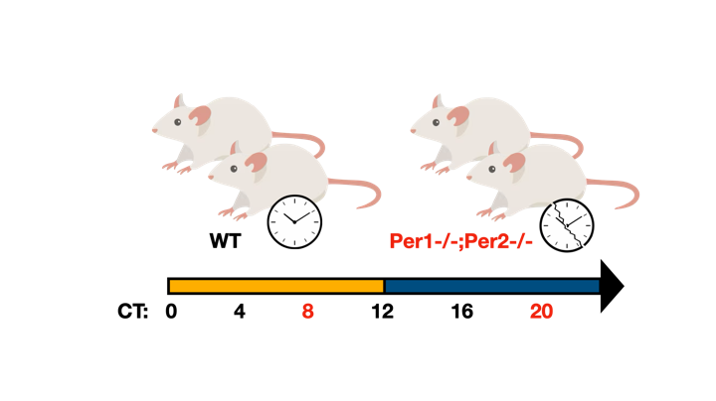
B
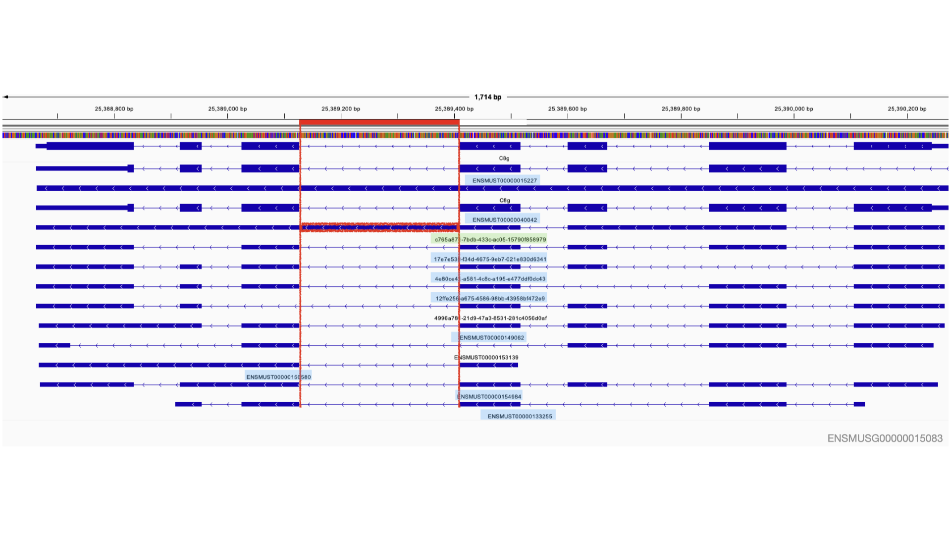
Figure B. IGV visualization of the C8g locus (chr2:25,389,127–25,389,410, variable mode). The red box marks the retained intron region detected only in variable mode. The novel transcript c765a871 (green) drives both the A3 and RI events at this locus. Light blue transcripts are total-only. Gene: ENSMUSG00000015083

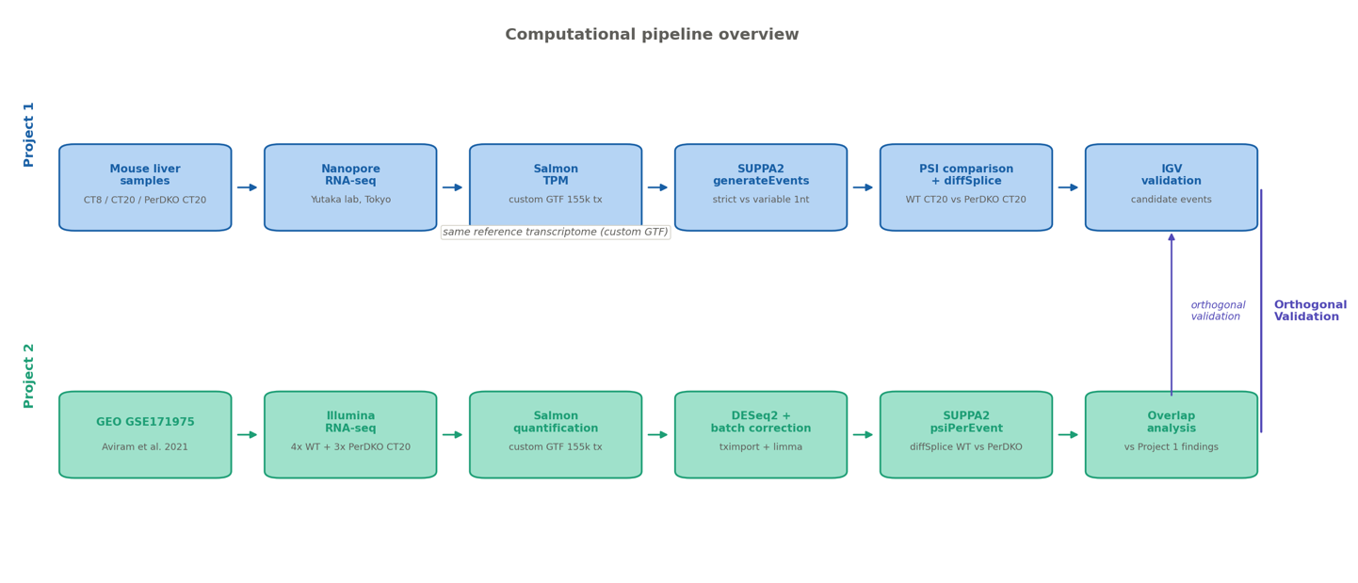
C

